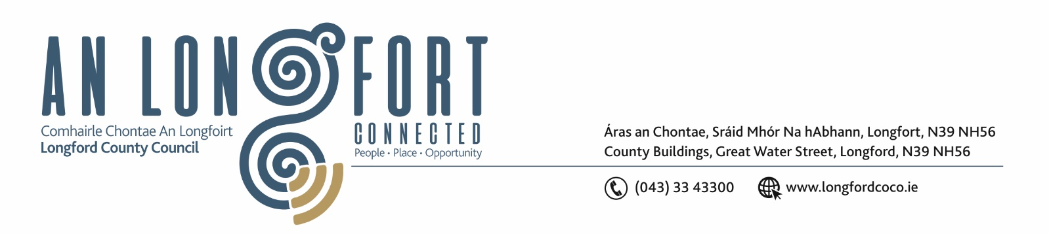
22nd July 2019.

To: Each Member of the Joint Policing Committee.

Re: Meeting of the Joint Policing Committee

Dear Member,

I wish to inform you that the inaugural meeting of the Joint Policing Committee will take place in the Council Chamber, Aras an Chontae, Great Water Street, Longford, on Monday, 29th July 2019 at
3.00 p.m.

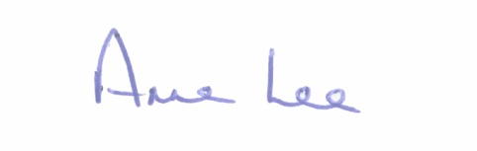
Yours sincerely,

___________________
Anne Lee,
Administrative Officer.

AGENDA

1. Confirmation of Minutes of Joint Policing Committee meeting held on the
4th March 2019 - enclosed.

2. Matters arising.

3. Declaration of Interest by Members.

4. Election of Chairperson of Joint Policing Committee.

5. Role and functions of the Joint Policing Committee – Guidelines enclosed.

/2………..

6. Identify community based interests – six members – to be represented on the Joint Policing Committee.

7. Garda Report.

8. Local Authority Report.

9. Update on Longford Joint Action Plan.

10. Date of next meeting.

